1. Calderón Jilmar

**RUBRIC**

*PART1*

**Theory Exercise:  8/15**

*PART2*

**Class Diagram: 10/10**

* Design the class diagram following the MVC pattern 5/5 points,
* Two GUI screens (menu, create/add, list), specifying the type of widgets you would use 5/5 points

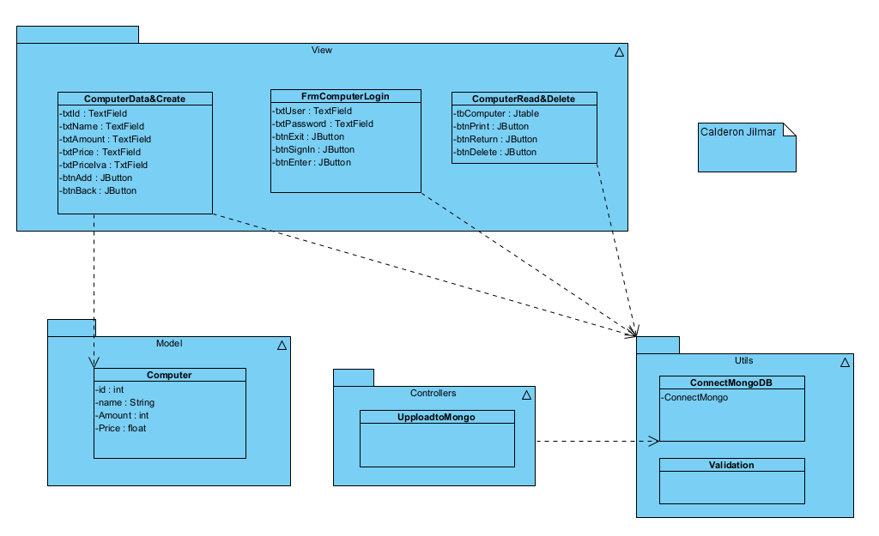

**Code: 29/30**

MVC:.......................... 5/5 pts

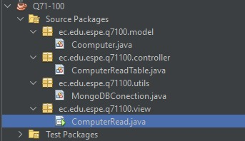

GUI implementation:. 5/5 pts. (Create: good use of widgets, read all: good use of tables)

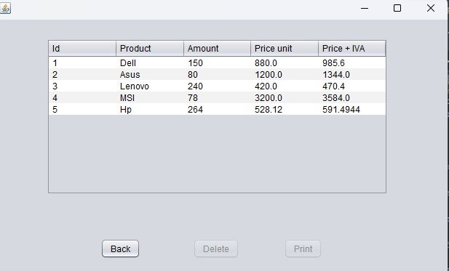

DB implementation:.. 5/5 pts.

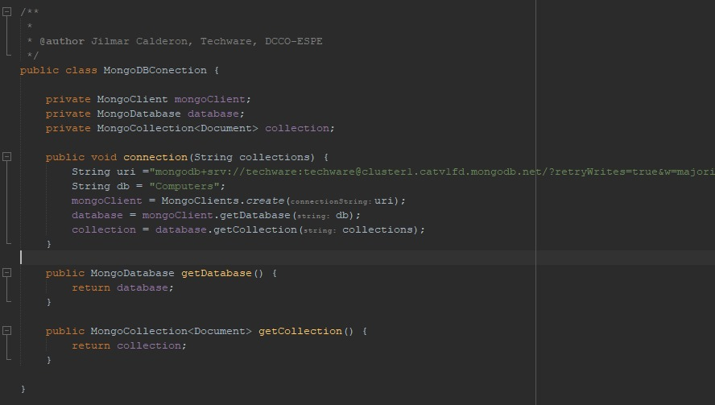

Data persistence:..... 10/10 pts. (your application inserts into MongoDB Atlas, your application read from MongoDB Atlas)

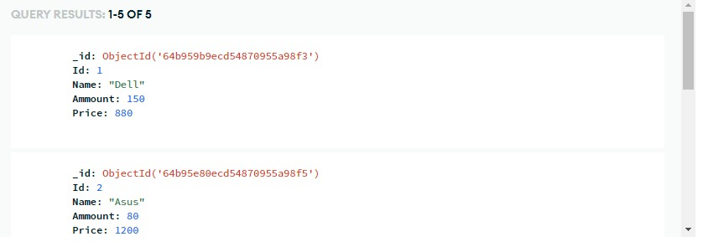

Clean code:................ 4/5 pts.

Killer: Gabriel Calvache